Description of Test | Test data to be used | Expected outcome | Actual outcome | Comments and intended actions | Date tested
Testing the business logo on the navigation bar | No test data required | Redirects user to the home page | The logo redirects the user successfully to the home page | PASS | 21/04/2026
Testing the home page link on the navigation bar | No test data required | Redirects user to the home page | The link redirects the user successfully to the home page | PASS | 21/04/2026
Testing the shop page link on the navigation bar | No test data required | Redirects user to the shop page | The link redirects the user successfully to the shop page | PASS | 21/04/2026
Testing the producers page link on the navigation bar | No test data required | Redirects user to the producers page | The link redirects the user successfully to the producers page | PASS | 21/04/2026
Testing the about us page link on the navigation bar | No test data required | Redirects user to the about us page | The link redirects the user successfully to the about us page | PASS | 21/04/2026
Testing the contact page link on the navigation bar | No test data required | Redirects user to the contact page | The link redirects the user successfully to the contact page | PASS | 21/04/2026
Testing the shopping cart page icon on the navigation bar when a user is not logged in | No test data required | Redirects user to the sign in page | The link redirects the user successfully to the sign in page | PASS  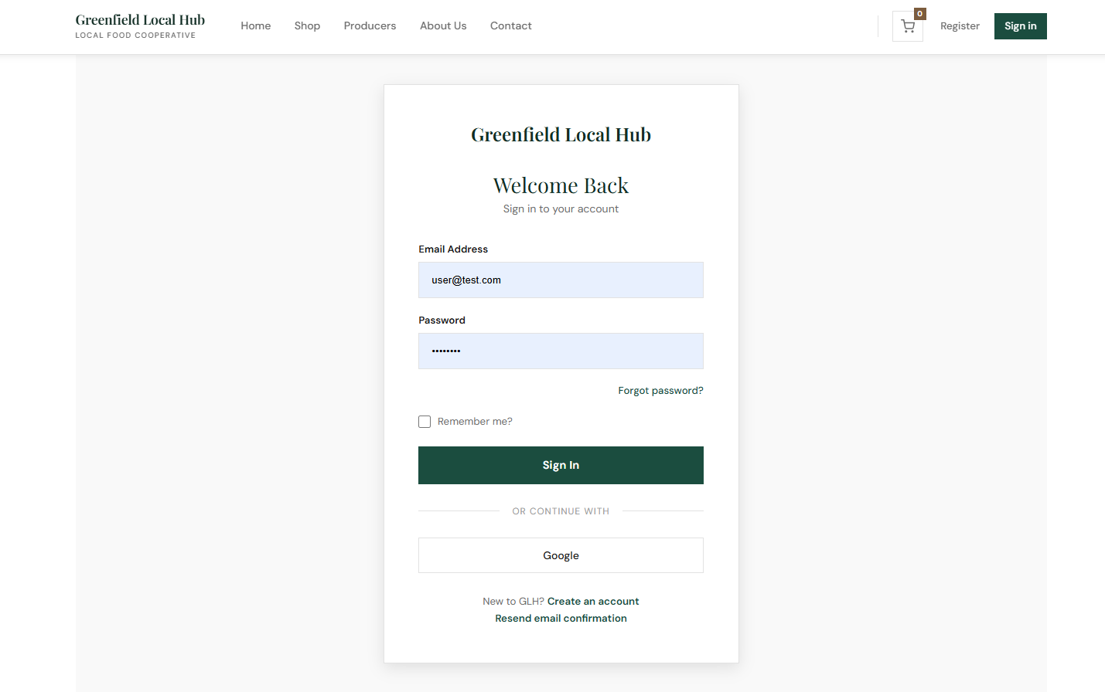 | 21/04/2026
Testing the shopping cart page icon on the navigation bar when a user is logged in | No test data required | Redirects user to the shopping cart page | The link redirects the user successfully to the shopping cart page | PASS  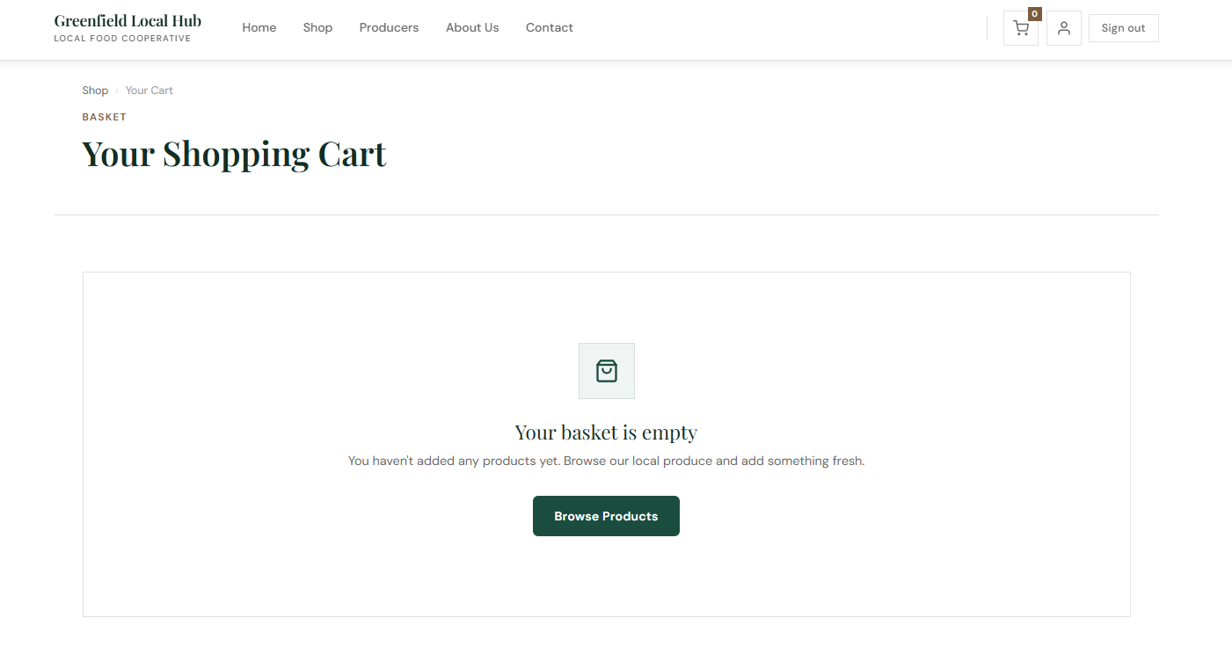 | 21/04/2026
Testing the register page link on the navigation bar | No test data required | Redirects user to the register page | The link redirects the user successfully to the register page | PASS | 21/04/2026
Testing the sign in page link on the navigation bar | No test data required | Redirects user to the sign in page | The link redirects the user successfully to the sign in page | PASS | 21/04/2026
Testing the account page icon on the navigation bar when a user is logged in | No test data required | Redirects user to the account page | The link redirects the user successfully to the account page | PASS | 21/04/2026
 |  |  |  |  | 21/04/2026
 |  |  |  |  | 21/04/2026
 |  |  |  |  | 21/04/2026
 |  |  |  |  | 21/04/2026
 |  |  |  |  | 21/04/2026
 |  |  |  |  | 21/04/2026
 |  |  |  |  | 21/04/2026
 |  |  |  |  | 21/04/2026
 |  |  |  |  | 21/04/2026
 |  |  |  |  | 21/04/2026
 |  |  |  |  | 21/04/2026
 |  |  |  |  | 21/04/2026
 |  |  |  |  | 21/04/2026
 |  |  |  |  | 21/04/2026
 |  |  |  |  | 21/04/2026
 |  |  |  |  | 21/04/2026
 |  |  |  |  | 21/04/2026

